OUT

CREATE OR REPLACE PROCEDURE query_emp

(p_id IN employees.empid%TYPE,

p_name OUT employees.lastname%TYPE,

p_salary OUT employees.salary%TYPE)

IS

BEGIN

SELECT lastname, salary INTO p_name, p_salary

FROM employees

WHERE empid = p_id;

END query_emp;

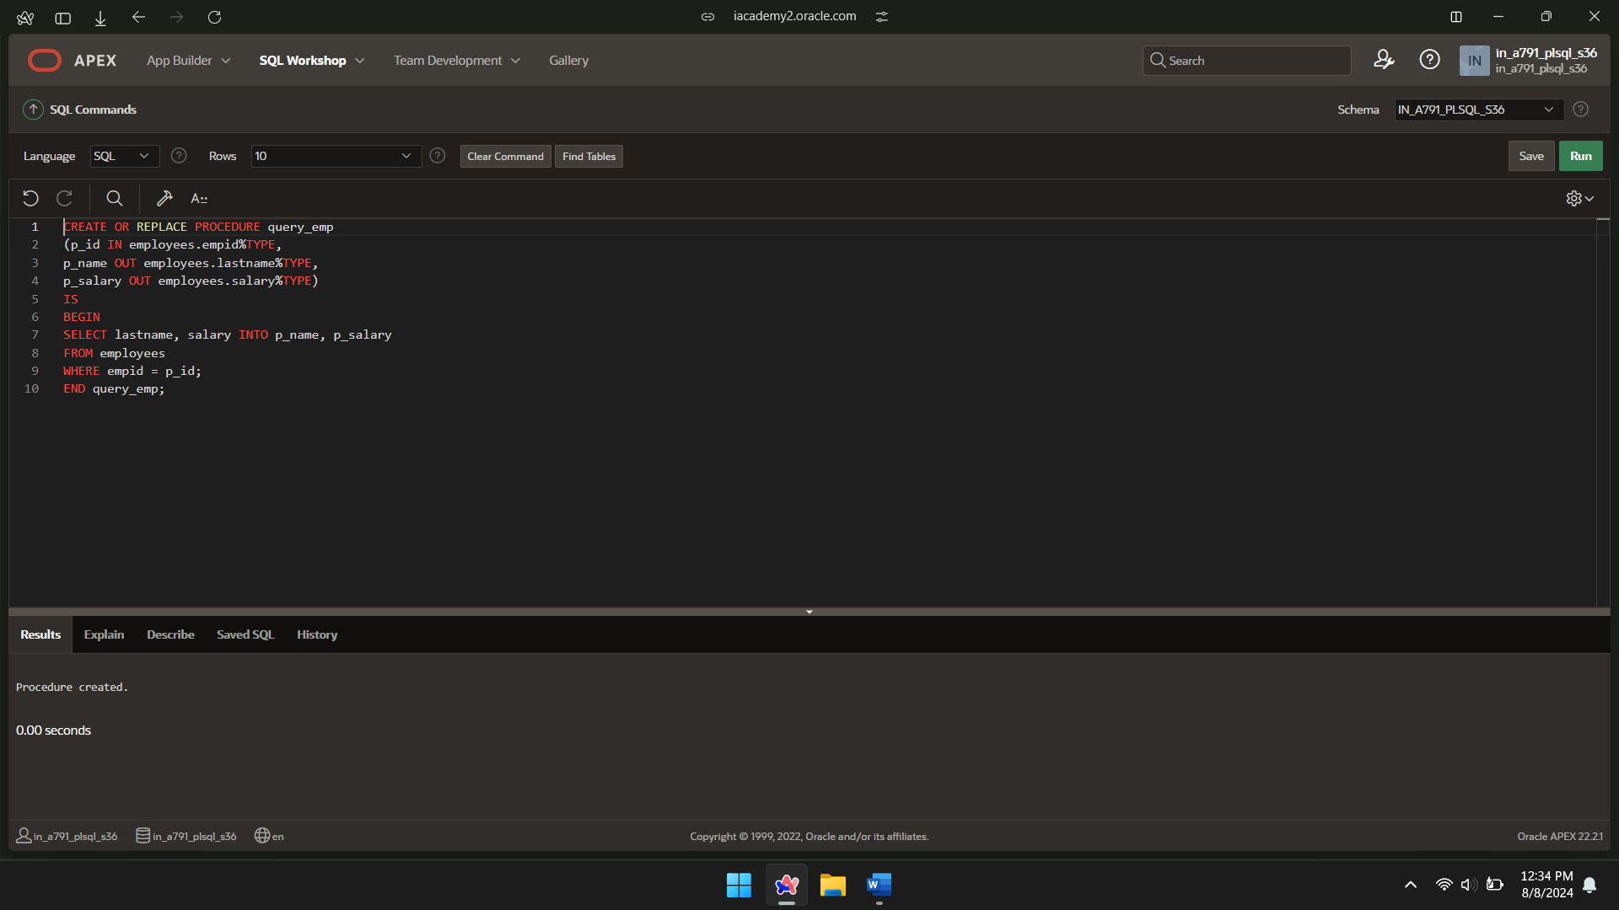

DECLARE

a_emp_name employees.lastname%TYPE;

a_emp_sal employees.salary%TYPE;

BEGIN

query_emp(102, a_emp_name, a_emp_sal);

DBMS_OUTPUT.PUT_LINE('Name: ' || a_emp_name);

DBMS_OUTPUT.PUT_LINE('Salary: ' || a_emp_sal);

END;

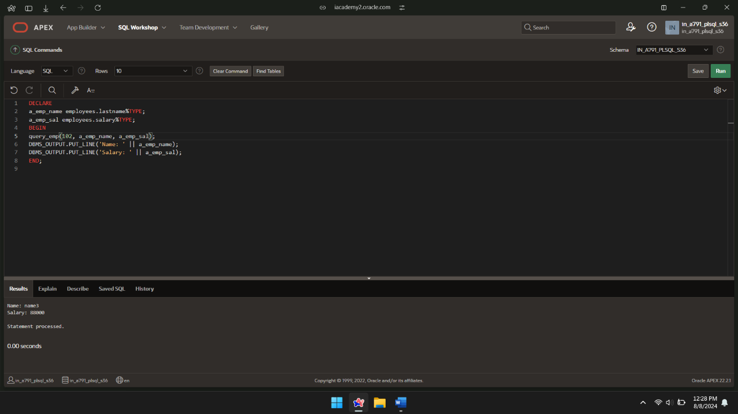

IN OUT

CREATE OR REPLACE PROCEDURE query_emp

(p_id IN employees.empid%TYPE,

p_name OUT employees.lastname%TYPE,

p_salary OUT employees.salary%TYPE)

IS

BEGIN

SELECT lastname, salary INTO p_name, p_salary

FROM employees

WHERE empid = p_id;

END query_emp;

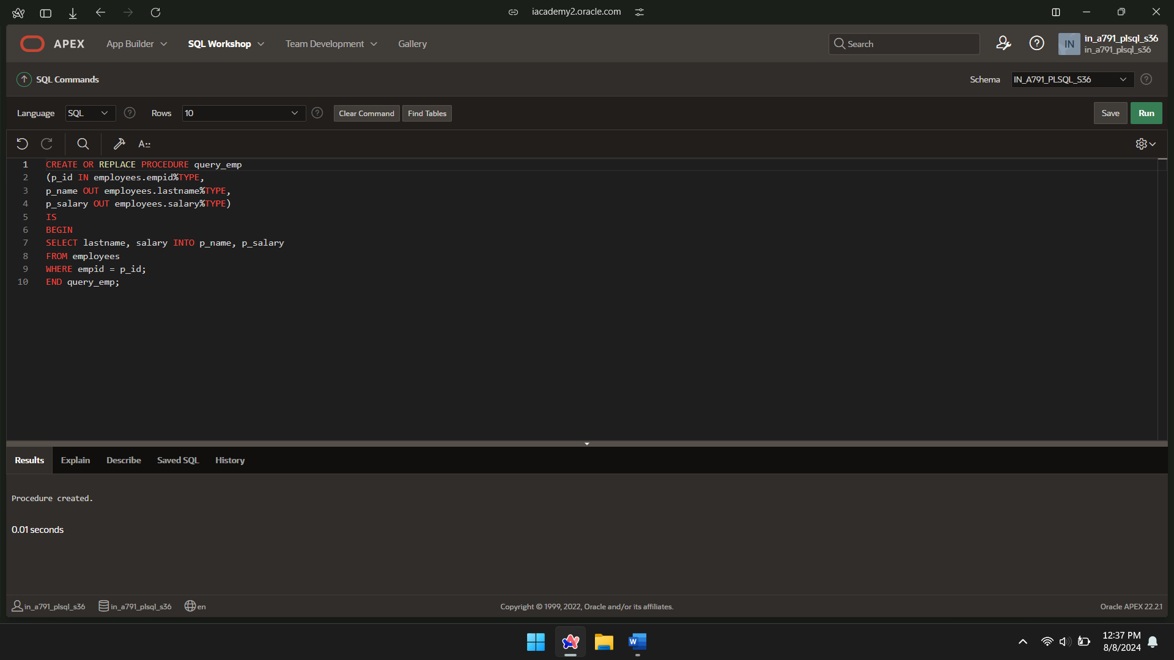

DECLARE

l_emp_id employees.empid%TYPE := 101;

l_new_salary employees.salary%TYPE := 50000;

BEGIN

update_employee_salary(l_emp_id, l_new_salary);

DBMS_OUTPUT.PUT_LINE('Updated Salary: ' || l_new_salary);

END;

/

